EUROPEAN NUTRIENT RECYCLING CONTEST QUESTIONNAIRIE
For selection of the best available nutrient recovery technologies and products.
Deployment/market uptake promotion of Nitrogen/Phosphorus recovery innovations
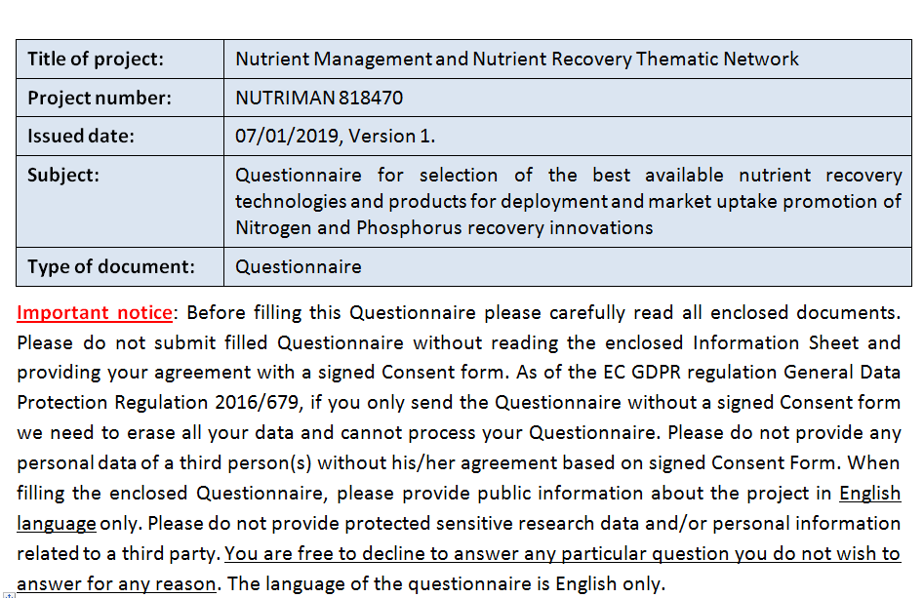
PART I. Data provider/CONTACT person
Data Provider is the person filling in this Questionnaire and signing the Consent Form
(Project Coordinator or Technology and/or Product owner):
 | Name and status of the responsible data provider :
 | Organisation:
 | Contact details (your address, e-mail, telephone):
 | Job title:
PART II: PROJECT related questions:
Project Full Title:
Project acronym:
Project website:
Name of the Programme (EU FP7, H2020, LIFE, national project or others)
Contract number:
Project duration:
Status of the project: |  | (on going, finished.. etc.)
Name of the coordinator organisation and coordinator:
In the case of you are a Project Partner a signed Consent Form is also needed from the Project Coordinator. Otherwise please do not send any personal data (e-mail, telephone, etc.) of third person.
Coordinator contact (e-mail):
In the case of you are a Project Partner a signed Consent Form is also needed from the Project Coordinator. Otherwise please do not send any personal data (e-mail, telephone, etc.) of third person.
List of project partners, or web links:
Short summary of the project (max chk 500)

PART III: technologies
Questions related to the practice oriented
Nitrogen and/or Phosphorus recovery technologies.
Name of the technology:
Qualified and quantified technology description:  (max chk 3,000) | - processing aim, process conditions , feed flexibility and description:  - energy/water use:  - added value innovative technical content:  - location:  - emissions and environmental/climate impacts (as of EU/MS regulations):
INPUT tons/year  and tons/hour: | - input material(s) specs, input material availability in economical industrial scale, logistics and cost/ton:  - at minimum economical industrial scale:  - scale up options:
OUTPUT tons/year and tons/hour: | - at minimum economical industrial scale:  - N/P nutrient concentration % and plant availability:  - Fertilizing product category selection:
Maturity and status description:  (max chk 1,000) | - development legend:  - TRL/IRL level or beyond:
Market competitive economics:
(max chk 1,000)
CAPEX in EURO | Capital Expenditure for economical industrial scale:
OPEX in EURO | Operational Expenditure for economical industrial scale:
Technology owner (s) and contacts:
If you are not the technology owner, a signed Consent Form is needed from the technology owner. Otherwise please do not send any personal data of third person.

IPR status: | (Intellectual property rights, such as industrial properties (industrial designs, models, know-how, patents) and copyrights, trademarks.
EC/MS Authority permits: | Permit number:  Issuing Authority:  Permit area:  Permit validity :
Short public summary of the technology:
(max chk 1,000)

PART IV: PRODUCTS
Questions related to the practice oriented recovered
Nitrogen and/or Phosphorus fertilizing products.
Name of the product:
Fertilizing product category selection as of EC Fertilizers Regulation revision COM (2016) 157 : | Please select from the following list:  - FERTILIZERS  - Organic fertilizers  - Organo-mineral fertilizers  - OTHER PRODUCTS  - Growing media  - Soil improvers  - Liming materials  - Plant bio-stimulants  - Agronomic additives
Status of the product development incl. TRL/IRL level in 2019:
Product owner (s) and contacts:
If you are not the product owner, a signed Consent Form is needed from the product owner. Otherwise please do not send any personal data of third person.
Input material(s) specification:
Quality characterization (Nutrients) as of EC Fertilizers Regulation revision COM (2016) 157: | Overall texture of the product (granulometry, moisture…)  Organic carbon content (% of dry matter by weight):  Total carbon content (% of dry matter by weight):  Total Nitrogen content % dry matter:  Phosphorus content mg/kg dry matter:  Other macro and micro elements (mg/kg dry matter):  Plant available nutrient content % (e.g water soluble, citric acid soluble nutrient content):  Dry matter content:  Particle density (g cm-3):  pH:
Product safety as of EC Fertilizers Regulation revision COM (2016) 157:: | Metals/metalloids: As, Cd, Cr, Cu, Hg, Ni, Pb, Zn (mg/kg dry matter):  PAH16 or PAH19 (mg/kg dry matter):  PCB6 (mg/kg dry matter):  PCDD/F (ng WHO Toxicity equivalents/kg dry matter):
In which EU countries and at what scale has your product been tested?
Has your product been tested under real farming conditions?
Is there any survey about the users' needs of acceptability?
Product economics, EXW whole sale:€cost/ton: | (EXWorks product availability at manufacturers location for professional large scale users)
User recommendations:  (max chk 1,000) | (incl. doses/ha, application conditions, formulations, aso…)
IPR status: | (Intellectual property rights, such as industrial properties (industrial designs, models, know-how, patents) and copyrights, trademarks.
EC/MS Authority permits for product use: | Permit number:  Issuing Authority:  Permit area:  Permit validity (crops):
Short public summary of the product:
(max chk 1,000)

Any additional information you would like to share:

https://ec.europa.eu/transparency/regdoc/rep/1/2016/EN/1-2016-157-EN-F1-1.PDF http://www.europarl.europa.eu/RegData/etudes/BRIE/2016/582010/EPRS_BRI(2016)582010_EN.pdf
https://nutriman.net/sites/default/files/2019-01/TRL_IRL_Technology_Readiness_Levels.pdf
https://ec.europa.eu/transparency/regdoc/rep/1/2016/EN/1-2016-157-EN-F1-1.PDF
https://nutriman.net/sites/default/files/2019-01/TRL_IRL_Technology_Readiness_Levels.pdf
https://ec.europa.eu/transparency/regdoc/rep/1/2016/EN/1-2016-157-EN-F1-1.PDF
https://ec.europa.eu/transparency/regdoc/rep/1/2016/EN/1-2016-157-EN-F1-1.PDF

